TALKING SCIENCE- A PROJECT IN RURAL BANGLADESH TO INCREASE SELF ESTEEM OF WOMEN THOUGH HEIGHTENING THEIR AWARENESS OF THEIR KNOWLEDGE OF SCIENCE AND TECHNOLOGY FROM THEIR EVERYDAY LIVES AND TALKING TO THEIR CHILDREN

In proceedings of Kuching ICASE conference, September 2013

Objectives

The objective of this project was to assist destitute poorly educated often illiterate women learn a trade so they could in future support their families in realising the science of everyday and how much they knew and enhancing their self esteem and communication with their children, mostly of pre school age.

Significance

Education is one of the three ‘jewels in the Commonwealth crown’ (Ramphal, S. (2009) The Commonwealth Millennium goals include education of women, of achieving primary education for all with emphasis on girls, enhancing science and engineering, improving literacy of women. This CASTME initiative is particularly concerned with the following two goals: Achieve universal primary education Promote gender equality and empower women. The project also contributes to other Millennium Development Goals of the Commonwealth and of UNESCO, particularly is to increase the literacy of women. Furthermore, learning in the pre school years is crucial to the development of children in a social community as well as in developing their knowledge amend understanding of the world (science and engineering) and acquiring literacy, talking and listening, then reading and writing.

The early years are crucial in the development of children and these first few years of child’s life are fundamentally important (Allen, 2011). The learning and the opportunities and experiences in these early years lay the firm foundations for later learning. They shape children’s future development, and influence how well children do at school, their on-going health and wellbeing and their achievements later in life. Such opportunities if not spontaneously and intuitively provided need to be planned and provided through early intervention strategies as recommended by some governments, (Allen, 2011). Pines and West (1986) showed that the impact of the knowledge that a child had acquired before they are taught formally a concept affects how they learn.

The person/s with children in these cortical first few years are their first teacher. Usually it is the mother, or another female relative providing the child care if them mother works. Thus it is of utmost importance that these first teachers are themselves literate, and talking and listening are the first two pillars of literacy, and understand how much that know from their tasks and observations in everyday lives of particular science and technology, without this bearing the label of science. `Providing these first teachers with self confidence, raising their self esteem and helping them to realise how much they know and how imprint it is to talk with the pre school, (and school) children could raise the science awareness in societies.

Theory
The Commonwealth has been concerned with literacy among the citizens of its constituent countries, particular that of women together with the issues of education for all. The Dakar Forum of 2000 reaffirmed the objective sofa the Jomlien Declaration of 1990 and set more specific goals for the Commonwealth (UNESCO 2000). The Millennium summit in New York in 2000 stated 2 goals peculiarly relevant to this paper; one to ensure all boys and girls completed a full course of primary schooling
The EFA, Education For All agenda is much broader than the MDG, Millennium Development Goals (Packer, 2012)

There are three countries in South Asia, India Pakistan and Bangladesh (49 million population in Bangladesh), which are in the ten countries with the most disadvantaged citizens. Adult literacy is the poor relation and lack of literacy skills continue to rise (Packer, 2012) near 17% of the world solution lack basic literacy skills and women are nearly 2/3rds of this. However, 85% of children in Bangladesh are now formally enrolled in primary education However, the rise in food prices is eliding to caldron being withdrawn from schooling with Bangladesh being one of the countries study and yielding data. However, Chanda (2012) states that female enrolment in pre primary Education is 9% of the population.

This initiative was to work with women who may be labelled illiterate in terms of reading and writing, to develop their oracy (which they have and many communities have a long history tradition of story telling) with emphasis on recognising the science and engineering phenomena in their everyday experiences. Women also talk to their children about the world. Learners with little or no formal education may not have the vocabulary to communicate their observations and experiences or they may misunderstand the words used, (Tunnicliffe and Uckert, 2011).
We believed that the self-esteem of women would be enhanced leading them to achieve other things. Learning begins with talking. Talking is the pre- cursor of reading and writing. At the foundations of learning science and technology we need to be encouraging observations and narratives about the living world that children encounter and planning such experiences for young children. The starting point for biology is observation. Children are intuitive scientists (Gopnik 2009). They observe, find patterns, hypothesize and try out ideas.
Children, we now know, need to talk, and to experience a rich diet of spoken language in order to think and learn. Reading, writing and number may be acknowledged as curriculum ‘basics’ but talk is the true foundation for teaching, (Alexander 2008). Narratives are important in learning science whether young or adult learner. Ogborn et al. (1996) argue that science knowledge can be reworked into story-like forms, fundamentally to act as an involving, memorable and efficient knowledge carrier
Design and procedure
The Mothers volunteered to participate in their own time The project was designed with the following components which were delivered in Bangla and recorded by the facilitator and responses translated into English. A. Initial questionnaire on basic science engineering in their lives and form where they found out about it. B. A mid project questionnaire/interview on what they had found out, whether they found this interesting. C. An End of Project interview and questionnaire as initial one.

The following activities were implemented in the free time of the women and children.
- Mothers take a science and engineering walk round the area with the co dominator looking with meaning. The co coordinator pointed out basic facts such as the plants all have green parts.
- Some animals have hair. Fur and are mammals, birds having feathers etc.
- Identify that which interests them.
- They took photographs and give reasons.
- They can select items that are of science or engineering significance and talk about them.
- Have their electronic photos printed and construct their own big books opt talk with their children
- Repeat the walk process with other Mothers
8) Family sciences Think and Do activities on rest days
9) Some workshops for older children on Think and Do activities

An example of a photograph taken, with reasons:
Talking Science Project
Shishu Polli Plus (Sreepur Village - UK)
Tengra, Sreepur, Gazipur, Bangladesh.

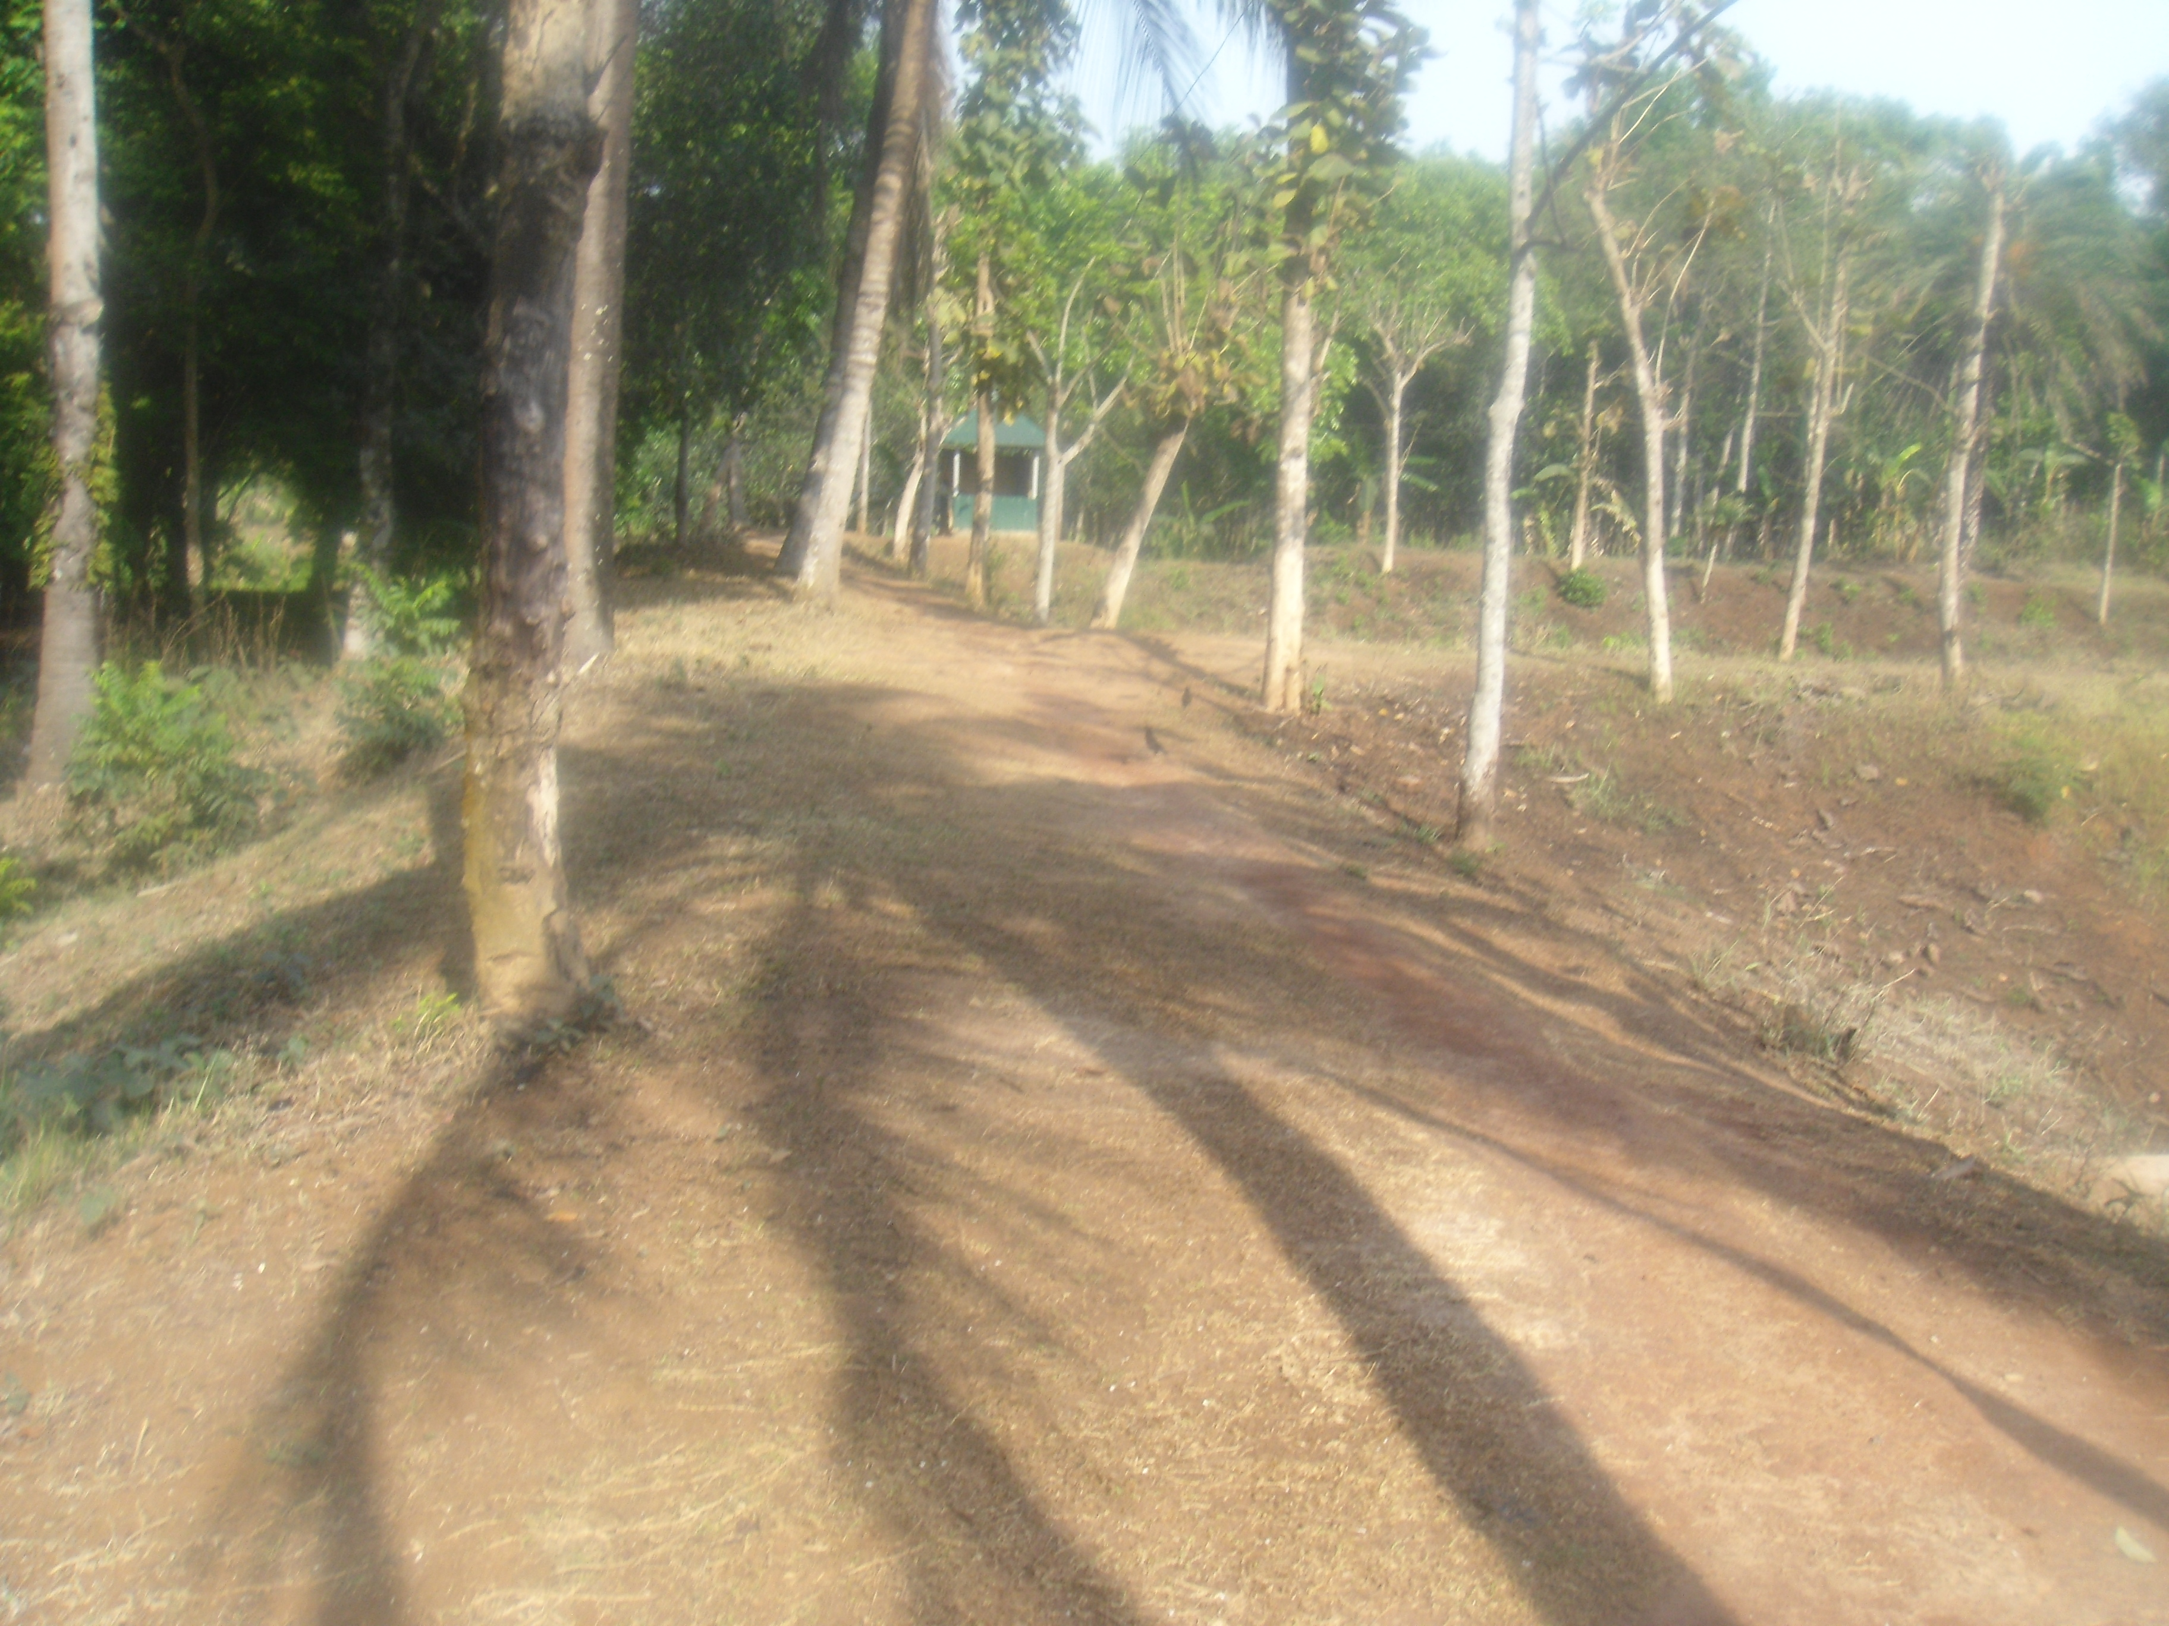
Take Camera and Take Picture activities

Date: 10.04.2012
Place: Shishu Polli Plus
Picture Taken by: Rouson

Explanation of Rouson Ara:

It’s a shadow of a plant

Findings
The initial interviews were analysed by a ‘read reread’ process until categories emerged.
data showed that half the women had children between 5 and 11 yrs., 14 ha children who were 12 one had one of 15 and 13 had preschool children. The women were in their thirties with a few younger and several older.

Understandings revealed by the first pre-project questionnaire showed a knowledge that eating was necessary to satisfy hunger. Twenty-seven mothers said we have to cook, as raw food is indigestible. All but two mothers recognised cooking, used ovens and food for cooking needed preparation, by for example, washing and cutting it up. Heat was needed and without it the changes of cooking were not possible. Washing hands was regarded as needed to keep clean and healthy by all and 14 said it was needed to keep healthy Fourteen respondents also stated that hand washing it stopped disease. Four mothers felt you became ill from dust therefore it was important to remove it.

Mid way through the project 4 % said they had learnt some science at school. Only ten translated questionnaire responses were received. We still await translation of the remaining response sheets. Other mothers said they had learnt science at this project, in particular the classification of living things, about plant nutrition, change in food with cooking and the structure of leaves fascinated over half of them as did machines such as cameras, mobile phones, and work machines. Yet they did not recognise many machines as such in their everyday lives.

End of project data were collected in January 2013 and then analysed, including interviews with the mothers who had been involved a d that were still resident at the village. After they have acquired skills, they return to their communities. We strove to elicit their feelings and whether the project has increased their appreciation of how much everyday science and engineering they know and their self-esteem. The Head of education and I composed the questions to ask. He asked them in Bangla and wrote the responses for me in English as they spoke, hence I was involved to a certain extent in the interviews. Many mothers brought their Big Books to show me, and I witnessed Mothers in their recreation time showing their books to other mothers and to children. There were twenty-two Mothers who were able to respond.

25.1.13.Mothers Talking Everyday Science with their Children End Questionnaire

Question | Total responses 22 Mothers | Sub category | Sub category
Did you enjoy/like Talking Science?  Why? | 22 | Can talk to others 3 learnt lot 5  Understand science 6 | Realise did science without knowing 1  Never had chance to learn science before 1
What did you like the most? | 27 | Cooking 7  Taking photos 6 physics 5 | About plants 6  Social aspects 2  Learning about germs 1
What did you like the least? | 0
How did it make you feel? | 22 | Good 8  More confidence 5 lucky have something to share 4 | Excited1  Bad not learnt before 2  Learnt things 2
What did you find out | 58 | About plants 25  Living/non 1  Everything has life1  What science is  Different kinds animals 1 | How to photo 3 gas stove things 5 cooking science 8  Physics things 21  Germs make sick 1
Did you realise you did science/engineering yourself every day in your life? E.g. cooking, sewing, washing? | 22 | Most of what we do is science | Doesn’t matter if we know it or not it is science
Did you know before Talking Science you are the most important teacher of your child? | 12 no  4 yes | Realise now
Did you enjoy Talking Science with -your child  . Using your Big Book?  Others? | 18  sharing with others 7  involving children 11 | Using big book and explaining 6  My child loves my pictures 3 I enjoy showing 1  Children fight to look 1 | Share with others proud, I know it 2  Know things now i can share with my children 3  I can talk to other mothers about it 2
9 Would you like to go one with Talking Science? | Yes 22 | For sake of children 2  Like to teach others 1  Wish others could learn too 3 sorry missed some clauses  I am sorry our teacher left 2

Overwhelmingly, the mothers enjoyed the project and were sad when it had to cease in the original form on the departure, for a job nearer his home, of the paid facilitator. Funding is being sought to continue the project. Meanwhile one of the staff who develops creative arts took the interested women on walks around the site identifying shapes and colours in the environment and introducing an element of science awareness.
The work, and particularly the Big Books constructed, provide the women with a focus with which to communicate with meaning with others and the self-esteem end confidence of the women was noticeably increased by their participation. They were proud to be recognised as the first teacher of their child and to have the chance to learn some science and particular to be involved with the digital camera and see the results!

NB in 2018 CASTME is seeking funds to continue the work with a facilitator.

References

Alexander, R. (2008) Towards Dialogic Teaching: rethinking classroom talk. Dialogos. York.
Allen, G. (2011) Early Interventions: The Next Steps. An independent report to her Majesty’s government. London. HM Government. www.dwp.gov.uk/docs/early-intervention-next-steps.pdf
Chanda, C. (2012) Gender and Education in the Commonwealth in Eds P. Williams and J, Unwick, Educational Co-operation: Jewel in the Commonwealth Crown. London Commonwealth Consortium for Education.
Gopnik, A. (2009) The Philosophical Baby: What Children's Minds Tell Us About Truth, Love, and the Meaning of Life. Farrar, Straus and Giroux, New York, USA
UNESCO (2000) Millennium Development Goals. accessed 6.11.12. http://www.who.int/topics/millennium_development_goals/en/
Ogborn, J., Kress, G., Martins, I., McGillicuddy, K. (1996) Explaining Science in the Classroom. Buckingham. Open University Press.
Packer, S. (2012) the Commonwealth and Education for All .i (Eds) P. Williams and J, Unwick, Educational Co-operation: Jewel in the Commonwealth Crown. London Commonwealth Consortium for Education. CCE
Pines, A., & West, L. (1986). Conceptual understanding and science learning: An interpretation of research within a sources-of knowledge framework. Science Education, 70(5) 583- 604. Ramphal, S (2009) Educational Jewel in the Commonwealth Crown. The Round table 98 (405) Tunnicliffe, S.D., and Ueckert, C. (2011). Early biology: the critical years for learning, Journal of Biological Education, 45:4, 173-175

