Interactive Activity sheet 14 for young children
SDGs included: 4 Education
Let’s think about AIR
Humans live on the rocky land part of our planet surrounded by air which we often call our ATMOSPHERE. This atmosphere is very important to human animals as we breathe it in. Without it we could not survive.

Air is a gas. Our air or atmosphere is made of lots of different gases but there are two very important ones, oxygen and water vapour gas. We can’t see oxygen but sometimes we can see the water vapour gas.
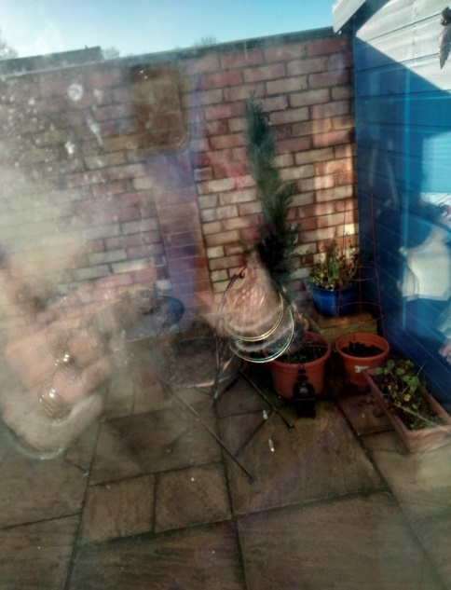

Look at the photograph. Perhaps you can see what might look like smoke? What you can see is a cloud of water vapour gas. My tumble dryer is sending out hot wet air into the colder air in the garden and we can see it because the cold air turns the water vapor gas into tiny droplets of water – a cloud really!
Sometimes you might see and feel the water vapour gas if you are standing in a fog or mist – or even in a cloud on top of a mountain!

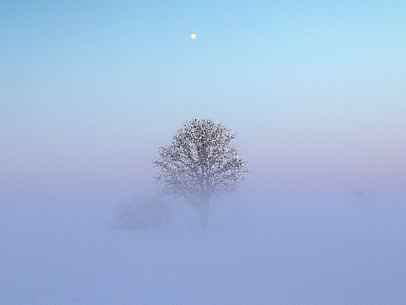
A foggy day

If you blow your warm breath onto a cold window you will see water droplets. This is the water vapour gas in your breath turning into water vapour droplets because the gas is cooled quickly. You might see this happening if you put a cold glass in a warm room – it gets all ‘steamed ‘up and this is the water vapour gas turning into water droplets again.

Our air or atmosphere is all around us and goes up to at least 6 miles high. But there is not enough oxygen up there to breathe without help!
As the air gets higher so it gets colder. When it gets cold we can see the water vapour gas as clouds. We get lots of different clouds which form at different heights. Have a look at any clouds in the sky and draw the different shapes!
There are lots of different types of clouds.

They all contain water vapour gas that you can see because it is cold and turning into water vapour droplets.

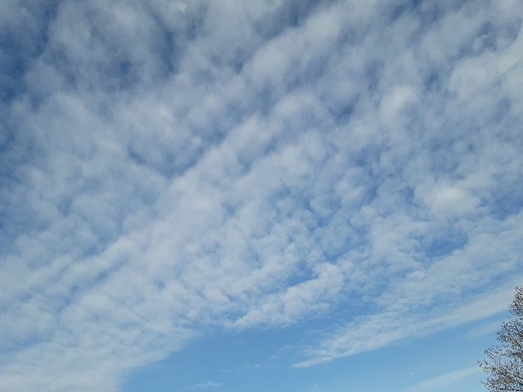
Very high clouds are made up of tiny ice crystals like the ones below in the photograph.
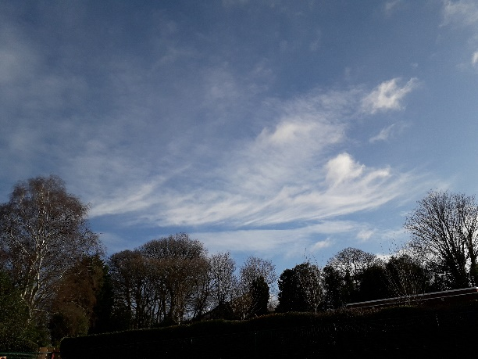

When aeroplanes are flying they produce exhaust gases which contain water vapour gas. You can see the aircraft trails in the sky as in the picture below. Because the aircraft are so high, the air is very cold and so the water vapour gas turns into ice crystals which we can see. We can follow the airplane across the sky.
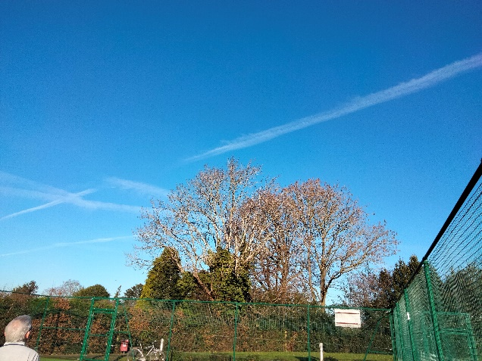
Most clouds are full of water vapour gas which can become water vapour droplets or RAIN but that’s another story!

Copyright Denise

