March 2021 Activity sheet 8: Sound again!
There are so many ways of making sounds. Clap your hands! This makes a flat sound. Try clapping your fingers, that makes a different sound! If you press the palms of your hands together when you clap, you get another sound.

Rainsticks make a lovely swishing sound so how about making a your own rainstick?

This involves a bit of technology and engineering so has lots of useful learning in it.
First of all gather together all the bits you are going to need: a small cardboard tube. This can be as long as you like but with a diameter not more than 5 or 6 cms.
You need some card – I used the back of a cereal packet. Pencil, scissors, sticky tape and of course some rice grains to make the rain sound!

Look at the photograph. I have numbered the pieces to help you. First draw around the top of the cardboard tube to make a circle (number 2). You need two of these. Cut out round the circle about half a centimetre away from your line so the circle is bigger than the hole on the top of the tube. Now cut into the circle up to the line to make a sort of frill around the edge of the circle. (in the photo number 1). Push the ‘frill’ up

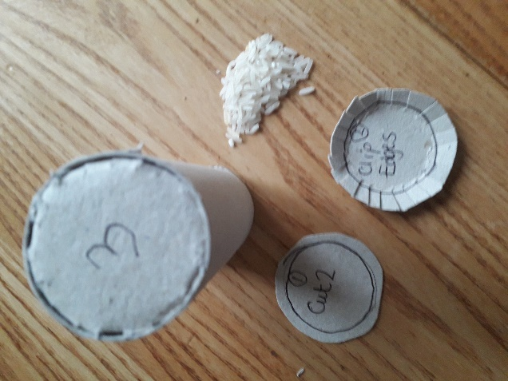

.
Now insert this piece onto the top of the tube (number 3). It’s a bit fiddly but will fit nicely, as the extra bits of the frill make it stay in place. You can secure it with the sticky tape.
Put the rice in the tube – don’t tip it up or it will fall out!! Now cut the second circle like the first and fit it into the tube. Secure with tape or glue. And you have a rainmaker. You can colour the outside or stick pretty paper or motifs on it.
If you use beans or even beads instead of rice you will get different sounds - so you can make several sticks – and have a whole band!
Another fun thing to make is your own matchbox guitar. You don’t have to use a matchbox, just a small box, but this was what I had lying around! Again, this requires some fiddling but you will good at this by now.
Find some different width elastic bands, that will go around your box. I used three. By plucking the elastic bands with my fingers I can get different notes or sounds – try it – its fun.

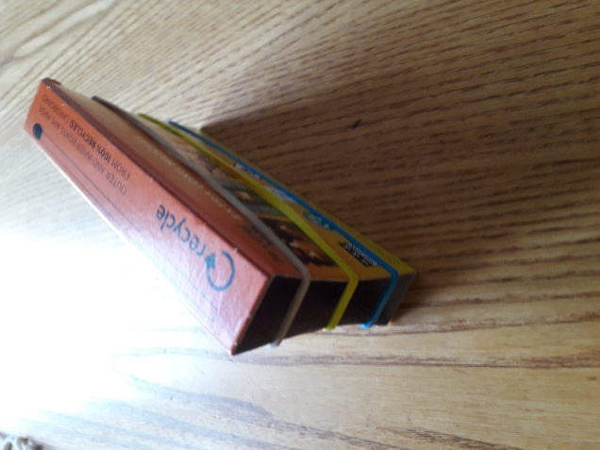
The photograph shows my matchbox guitar with three elastic band ‘strings’.
You have all sorts of different sounds now – perhaps you have a baby’s rattle in your house you can use too. Get your friends together and make music as a band!

Everyone can make music! Can you whistle? Ask a grown up to show you. And everyone knows how to sing!
There are many different sounds inside your home. Shut your eyes and listen to them. Can you work out what they are – sometimes there are squeaks made from a door that needs some oil. You might hear water dripping or making a noise in the pipes. Can you hear footsteps – everyone makes a different footstep so can you identify your family from their footsteps. You may have a pet – what sort of sound does it make – a bark, a miaow or a squeak?

When you go outside there are more sounds, that you hear better with your eyes shut. This might be the wind – a gentle sound or a stormy sound. You could be lucky and hear the sea waves. Sometimes they are gentle and sometimes very loud and scary as they bash onto the shore. Listen to rain – is it gentle rain or a heavy down pour?

Get used to taking notice of the sounds that are going on around you. Listening is a really good skill you can develop!
So now you are an engineer and a good listener.
Have fun with science.

Copyright Denise and Sue

