Activity sheet 8 Light
What is light? No, we are not talking about the opposite of heavy - we are talking about visible light. The opposite to dark. Light is actually energy that we can see – like sunlight!
If you stand with your back to the sun or a light you will have a shadow in front of you. This is because the light can’t pass through you! You can change the shape of your shadow by stretching up or bending down and your shadow will do the same.
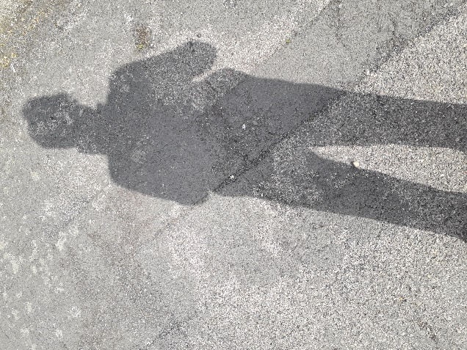
My shadow looks like a giant!!

Make a sun clock using shadows, its quite easy.
You need to find a spot that can be sunny all day, without getting the shadows of buildings on it. Plant a stick in the middle of this area, your stick needs to be about 1 metre in length if possible. At 0900 go outside and mark the end of the stick’s shadow perhaps with a small stick with some colour on it. This is your 0900 shadow. Do the same at 1200, and 1500 too. Depending on where you live, you may be able to mark 1800, although in some places the sun has nearly set by then. When you go back to your clock on another sunny day you can estimate the time from the position of the shadow.
What you might notice is that the shadows change length depending on the time of the year too. This is because the sun is at a different height in the sky. If you live near the equator, there will be very little change but if you are outside the tropics you will see great differences. Talk to a grown up about what you notice!
Another fun thing to do is to make shadow puppets. Using your fingers with the light behind you, make shapes onto a plain surface, perhaps a wall. By moving your fingers around you can make ears, a nose and a mouth that opens and shuts! You can make real monsters or butterflies using two hands. There are many websites which show you how to make different pictures.
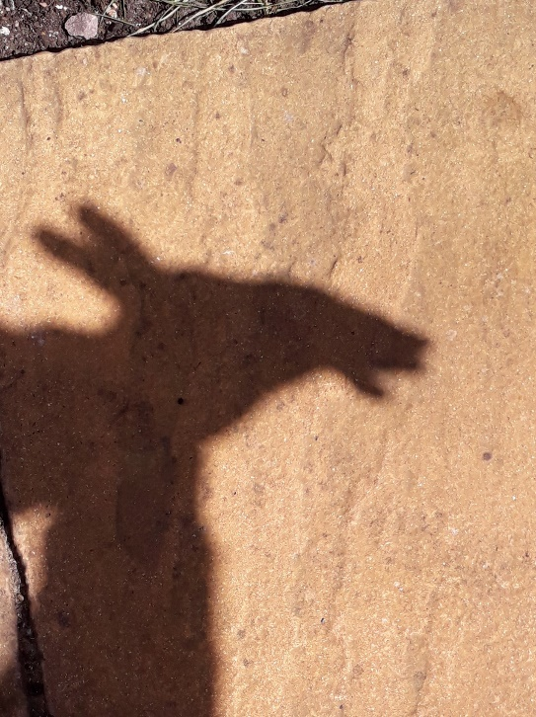

Light usually travels in straight lines but you can make it bend. Put a straight straw into a glass of water.
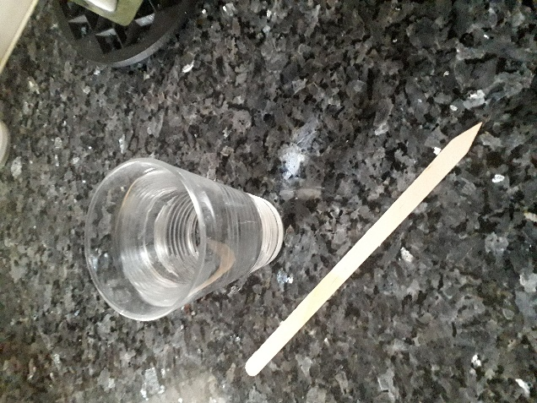

If you peer through the side of the glass your straw will look as though it is bent! This is a clever science process. When light moves from the air through the glass it changes direction - you will learn why when you are much older – but it does appear to be magical.
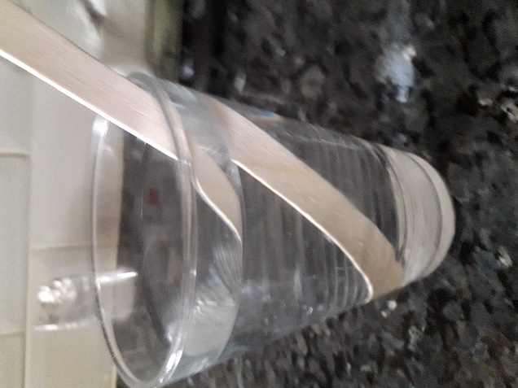

You can also split light up into its various colours. we usually see ‘white’ light. But when it rains and we stand between the sun and the rain we can see a rainbow. This is because the water droplets split the light up into its different wave lengths which show up as different colours. You can make your own rainbow by spraying water from a hose in front of you with the sun behind you.

Look around and you will often find where the light has been split – there are rainbows in lots of places. Light coming through a window onto a mirror or a glass sometimes has a rainbow effect.

And here is some interesting information about light.
Did you know that the light from the sun travels 300,000 kilometres to get to us and takes eight minutes to reach us? Wow!! Light travels in straight lines but it can bounce off things – we call this ‘refraction’. Light can pass through some things which are transparent or ‘see through’ like glass’. Other things let some light through but it’s a bit foggy or misty – we call these things translucent. But some things won’t let any light through and these are called ‘opaque’

Enjoy playing with light its fun!

Copyright Denise

