Activities sheet 11 Energy
Another word that grown ups often use is ‘energy : they will say “ you’ve got lots of energy” when you are rushing around and jumping up and down. But what does energy mean? What is energy? Let’s find out.
If we look up the word energy it means ‘the ability to do work’ or ‘vigorous activity’. So when you are jumping up and down (with vigorous energy) you have power to do this jumping or work. But where do you get this power or energy from? You can’t go and buy it! you get your energy from FOOD. And just about all the food you eat gets its energy from the SUN! Our sun sends this energy to earth through waves – like the waves that use Wifi – you can’t see them. Plants pick up this energy through their leaves and it makes them grow. Animals eat the plants and so get energy passed on to them. So if you eat plants, or meat or eggs, or drink milk they all have energy that has come originally from the sun.
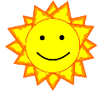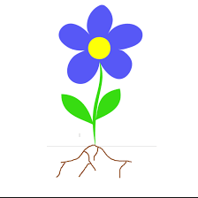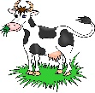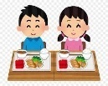
But what do you do with this energy? You may think, or move, or play. Perhaps if you throw a ball, you pass the energy on to the ball so it moves! If you run you will use up some energy and get hungry. You will need more food to give you more energy!!
Get a grown up to take you for a walk. Look for solar panels (the grown up will show you these), they are usually on the roofs of houses, or sometimes big panels on the ground facing the sun. these panels are clever and can turn the sun’s energy into something useful like electricity which can be used to make all sorts of things work.
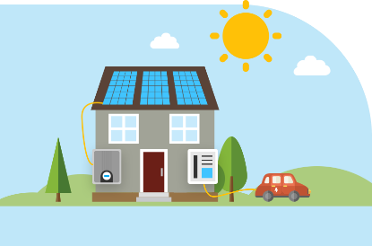
Lots of household equipment works by using electricity – ovens, TV, computers. Make a list of things in your house that use electricity to make them work. Solar panels can also heat up water for your home, or you may even have a solar cooker!
The wind is another form of energy that the sun controls. The sun heats up certain types of ground materials quicker than others, roads and buildings heat up quicker than soil and plants. A wind moves heat from a warm place to a cooler place. You might have wind turbines near you which are being turned by the wind and which are using wind energy to make electricity!
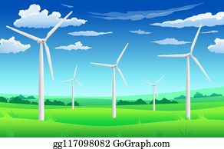
So now you know three different kinds of energy – your energy from food, solar energy from the sun and wind powered energy. If we make electricity and other energy from wind, and sun we call these Renewable Resources and this is much better for our planet than using oil, gas or coal which are causing climate change problems.
Can you find some of these different types of energy – heat energy, sound energy, light energy, water energy. Go and be an energy detective!
You can make use of water energy by making a water wheel which can lift a bar of sweets!
You will need; an empty drinks bottle with a lid, a piece of dowel (a thin stick) a plastic margarine tub, some elastic bands and some string. And a grown up to help!!
Get the grown up to make a hole through the lid and bottom of the bottle so that the stick can be pushed through – but don’t make the hole too big.
Now cut the margarine box. Cut out the ends, so you have a U shape. Cut this in half so you have two U shapes the same size. Now cut along the bottom of the U to give you shaped pieces as in the diagram. You need at least four of these flanges.
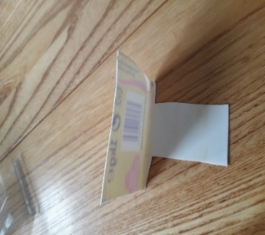
Use the elastic bands to attach these pieces to the side of your bottle to make a wheel of cups. Like the picture. I only had a clear plastic box and made 6 flanges.
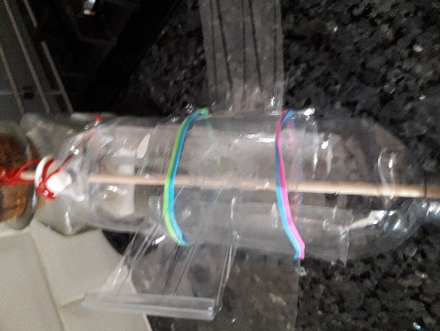
When you put the bottle stick across the top of a bucket or a sink and let water pour onto the flanges the bottle will turn. The faster the water flow the quicker your water wheel with turn. If you make 6 flanges, your wheel will turn faster. Now tie a piece of string to one end of the stick. Measure out about one metre and tie your tube of sweets to the other end. Make your water wheel turn and it will wind up the tube of sweets.
Another way to make a wheel is by using 4 paper cups and 2 paper plates – but this will go soggy when it gets really wet.
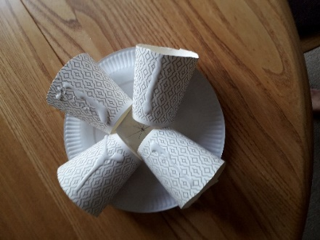
Stick the second plate on top of the cups – it’s a bit tricky and sticky but persevere. Then push a stick through the middle. This will rotate with wind or water, and if you tie a piece of string to the stick you can wind things up!
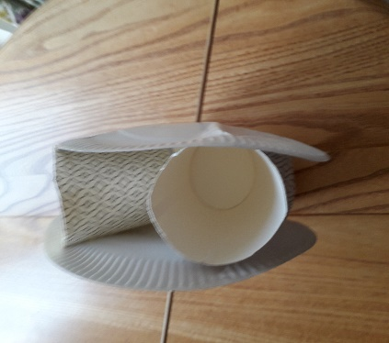
You have turned water falling and wind into energy! Well done! Be careful how you use energy and remember to switch off electrical things you are not using so you save energy.
Excellent!
Copyright Denise

